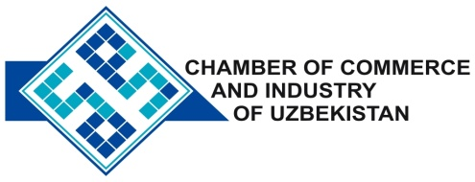

**Commercial offer of Uzbek Products to Foreign Buyer**

Dear Sirs, KP-004

We offer quotation of Uzbek Company CEEP "Hi-Tech Kabel"

**Information about the company:**

The company "Hi-Tech Kabel" was founded in 2006. The main activity of the company is production of cable and wire products. Our products are made on the equipment of such leading brands as «Rosenthal» (Austria), «TroesterGmbH» (Germany), «High-Volt» (Germany), «Nokia» (Finland), «Samp» (Italy).

**List of products:**

Power cables (up to 10 kV), control cables, wires and mounting household, self-supporting insulated wires (vultures).

**Benefits:**

Available technological equipment provides high quality products, meeting the Republic of Uzbekistan and the Russian Federation standards. All products have certificates of compliance with the Republic of Uzbekistan.

**Terms of delivery:** FCA Tashkent

If you are interested, we are happy to provide additional information in accordance with your request.

E-mail: export@chamber.uz

Website: www.chamber.uz

Export Promotion Department .

Chamber of Commerce of the Republic of Uzbekistan .